REPORT – STUDY TOUR 2019
Destination: BHOPAL- BHIMBETIKA –UDAYGIRI – SANCHI
This tour was specially organized for Final Year B.F.A. (Applied Art) students of 2019-20 batch of Rachana Sansad College Of Applied Art and Craft.
Dates: 15.11.19 – 21.11.19
41 students of FINAL YEAR B.F.A. Degree course and 3 faculties, Mrs Aditi Jha, Associate Professor, Mr. Vivek Tetwilkar, Asst. Professor & Mr Ameya Kadam, Asst. Professor attended this tour.
Day 1: 15.11.19
Departure from Mumbai CST at 19.30hrs to Bhopal By 12137 PANJAB MAIL.
Day 2: 16. 11.19
Arrival at Bhopal station at 9.30 am and checked into Hotel Pangat Residency, Maharaja Pratap Road, Bhopal.
After lunch explored the city. Visited the famous Moti Masjid, Taj-Ul Masjid, Gauhar Mahal and Bharat Bhavan.
Students were enthralled by the beauty of the monuments and indulged wholeheartedly in photography and sketching.

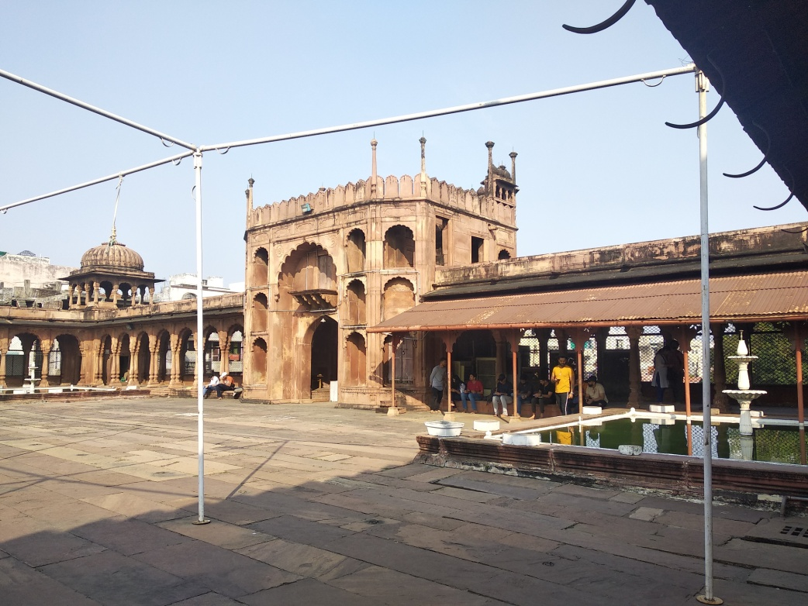
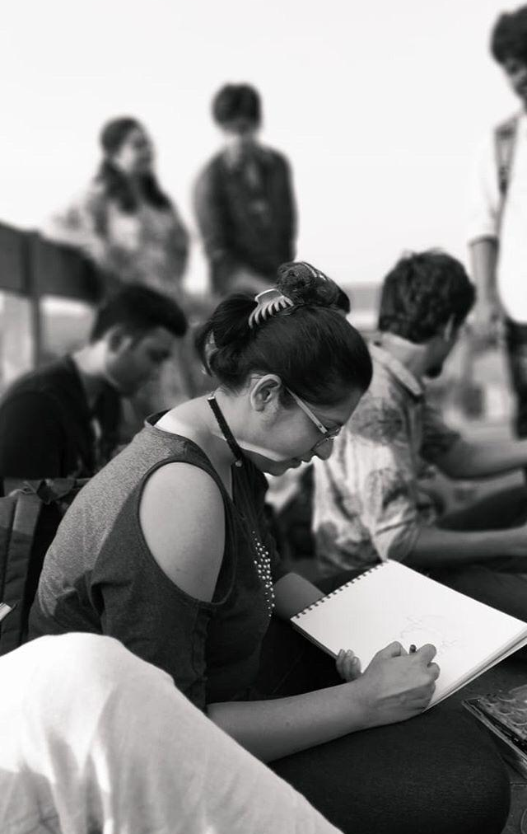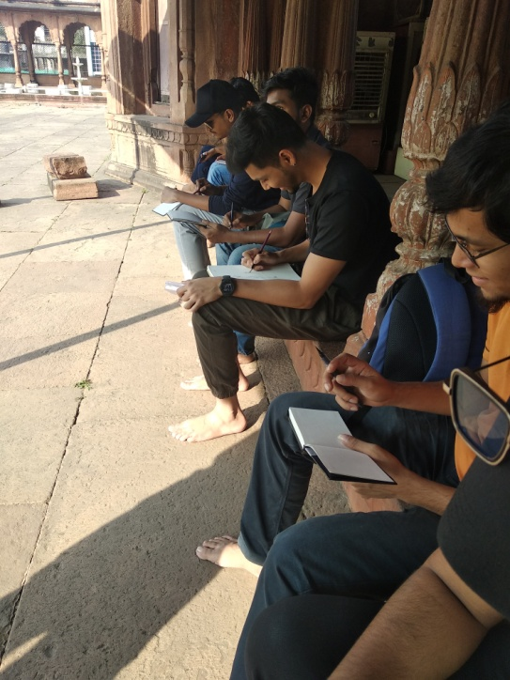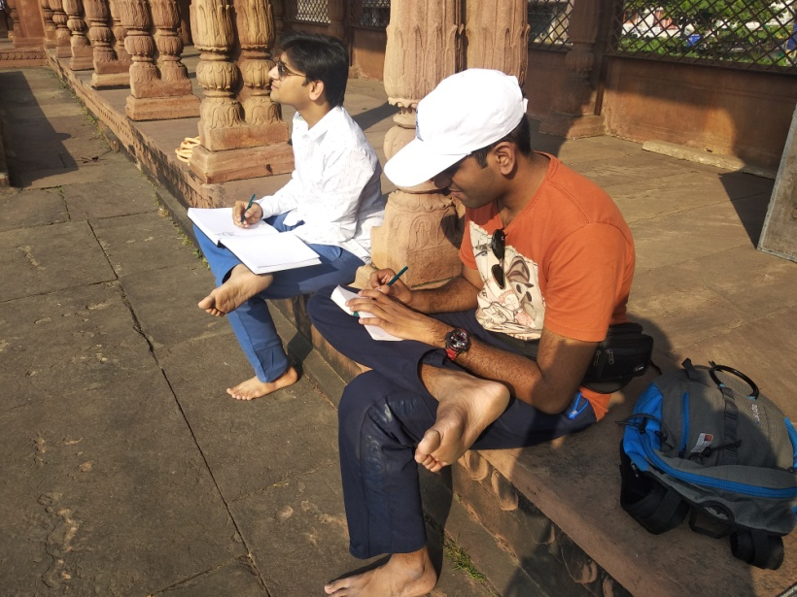
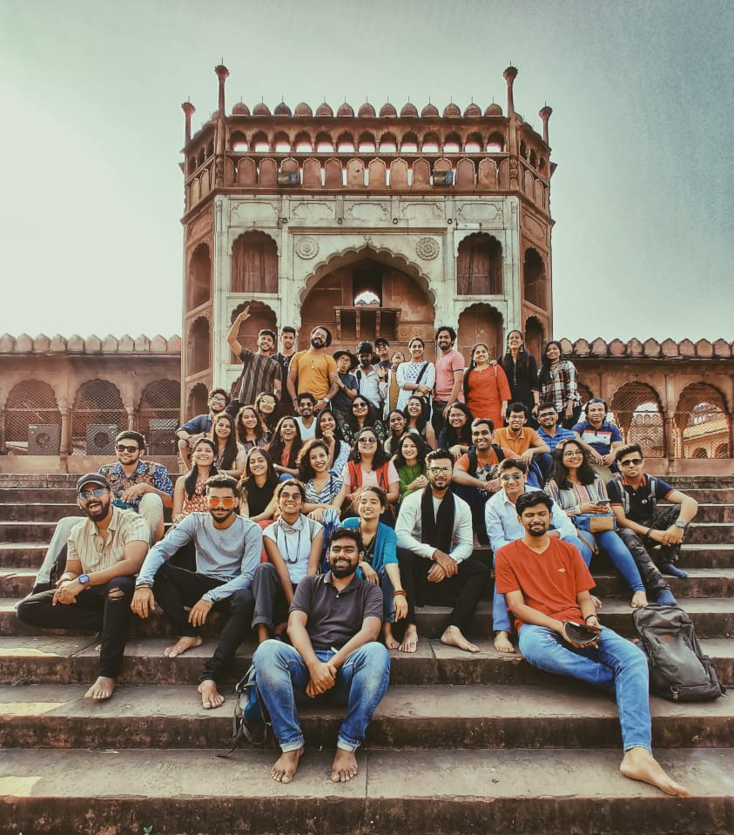
Sunset at Bharat-Bhavan was a visual treat. The displays of the works of eminent artists like Suza, Raza, Hussain, Jatin Das, Manu Parekh, and many more enriched the students.
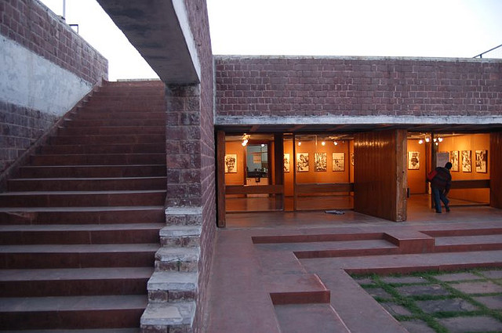
Finally returned to the hotel and retired after dinner.
Day 3: 17.11.19
A day packed with knowledge and enlightenment. After breakfast students visited Indira Gandhi Manav Sangrahalaya (IGRMS) or National Museum of Humankind or Museum of Man is an anthropology museum located in Bhopal, India, to present an integrated story of the evolution of man and culture with special reference to India. It spreads over an area of about 200 acres on the Shyamla Hills in the city. Students learnt about the the story of mankind in time and space. a) Open-exhibitions, b) Indoor galleries (Veethi-Sankul and Bhopal Gallery) and c) Periodical/ Temporary exhibitions which depicted Tribal Habitat, Coastal Village, Desert Village, Himalayan Village, Mythological Trail, Traditional Technology park.
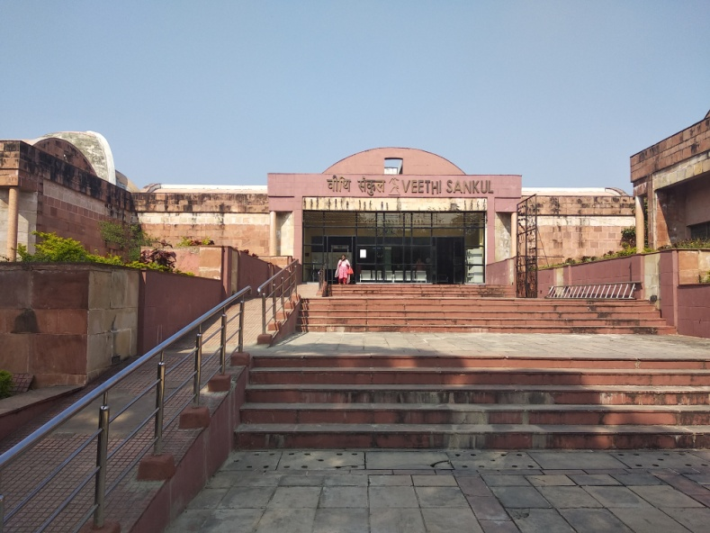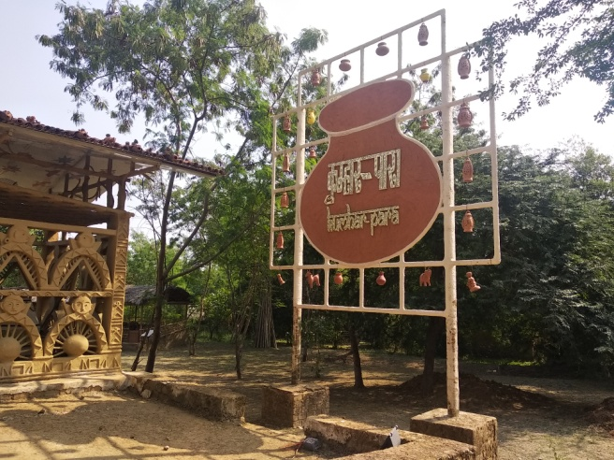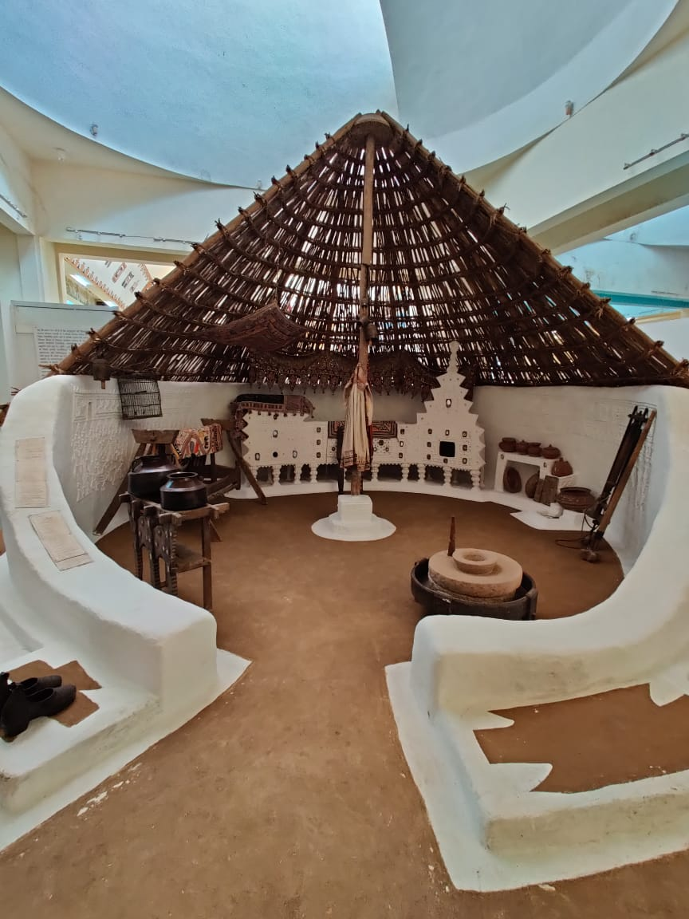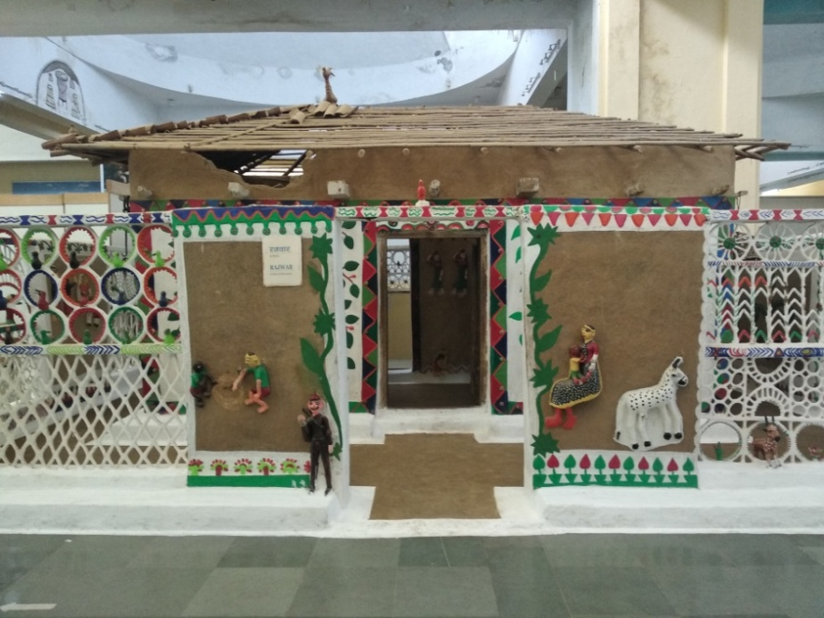
Post lunch was the visit to Tribal Art Museum. The biggest attraction of tribal museum is its well planned and beautifully placed themed galleries where every visitor is able to connect via motifs and artifacts representing tribal lifestyle. The museum indeed stands out from rest of the museums because of the way its exhibits are put up.
This Museum celebrates the ways of life practiced by the seven major tribes in the state – the Gond, Bhil, Korku, Baiga, Sahariya, Kol and Bhariya – through their crafts. In a series of colorful galleries whose roofs soar as high as three-storey buildings, the dramatically-lit artifacts project tribal living, aesthetics, and spiritual beliefs, Students were in love with the museum as in whole.
Retaining the authenticity and richness of the tribal culture and traditions, the gallery showcases the homes of the tribes-Gond,Korku, Bhil, Sahariya, while highlighting their dependency on natural resources. The Devloks, rituals, Gods, superstitions and sacrifices are also presented in a separate gallery. A whole gallery is dedicated to tribal games, very aesthetically curated.
Alongside taking a look at the beautifully designed galleries in the museum one we also stopped at an amphitheater inside the museum where we witnessed musical performances and cultural dances.
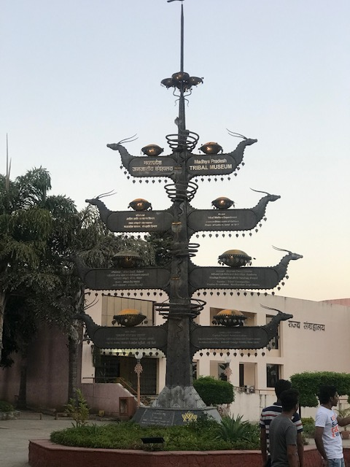
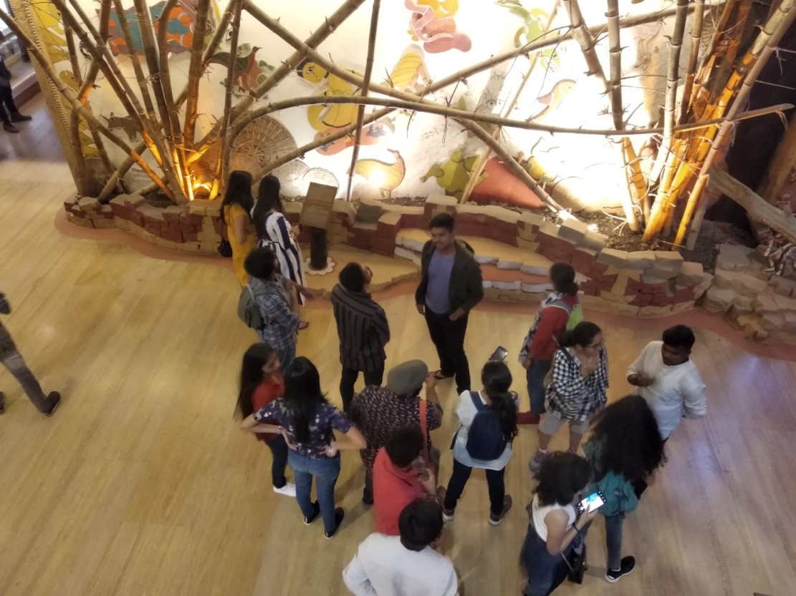
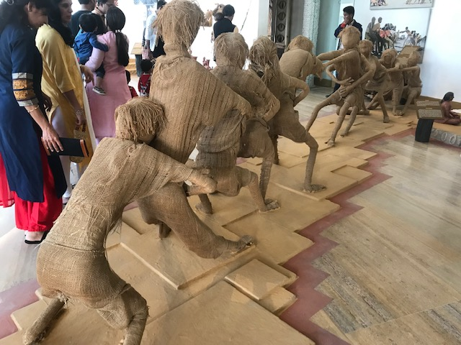
Overall, a very satisfying and informative day, the entire team was soaked in indigenous tribal lifestyle. Ended the day with a sumptuous dinner.

Day 4: 18.11.19
Visit to Bhimbetka rock shelters, which are an archaeological site that spans the prehistoric paleolithic and mesolithic periods, as well as the historic period. It is located in the Raisen District in the Indian state of Madhya Pradesh about 45 km southeast of Bhopal. It is a UNESCO world heritage site that consists of seven hills and over 750 rock shelters distributed over 10 kilometers. At least some of the shelters were inhabited more than 100,000 years ago.
There were linear representations, in green and dark red, of huge figures of animals such as bison, tigers and rhinoceroses. In addition to animals there are human figures and hunting scenes, giving a clear picture of the weapons they used: barbed spears, pointed sticks, bows and arrows. Some scenes are interpreted as depicting tribal war between three tribes symbolized by their animal totems. The depiction of communal dances, birds, musical instruments, mothers and children, pregnant women, men carrying dead animals, drinking and burials appear in rhythmic movement.
Everyone was awestruck by the history and visual representation. Students indulged in photography, sketching and landscape study.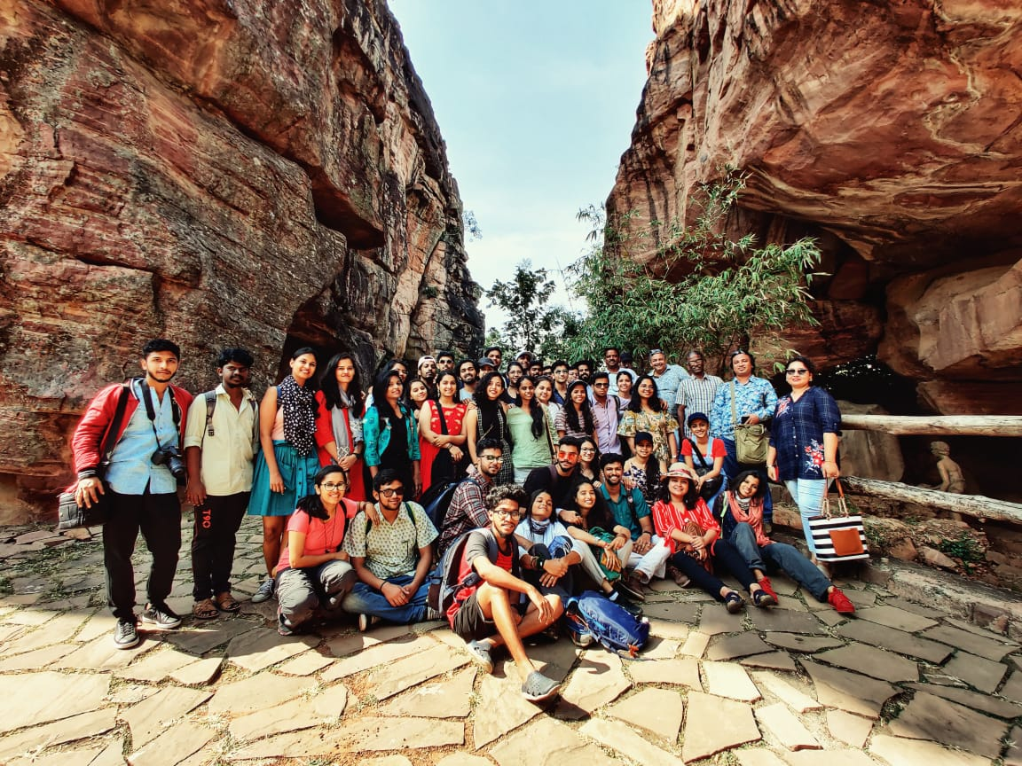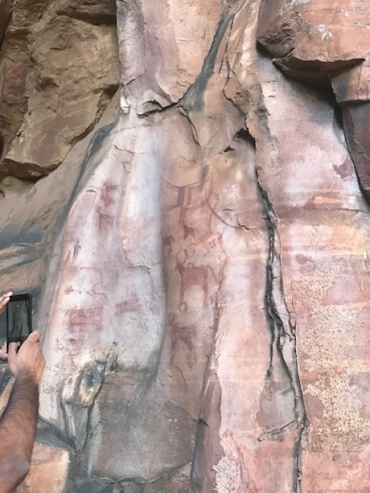
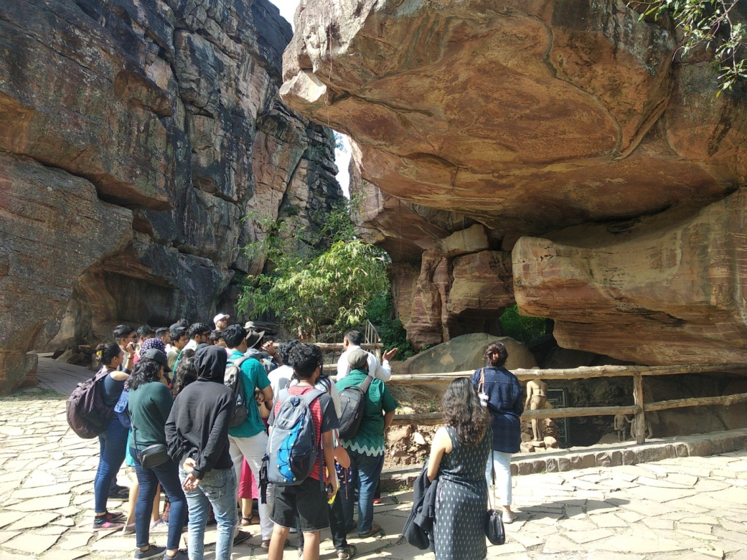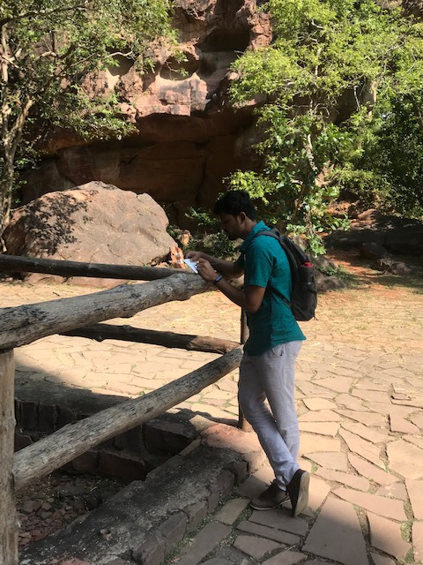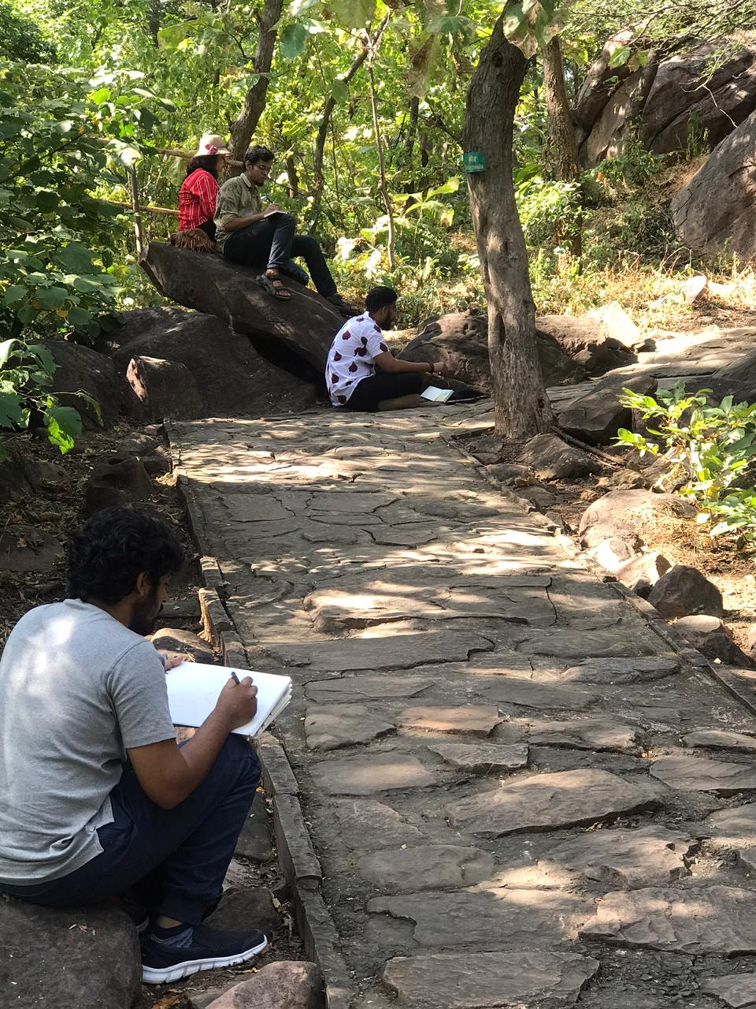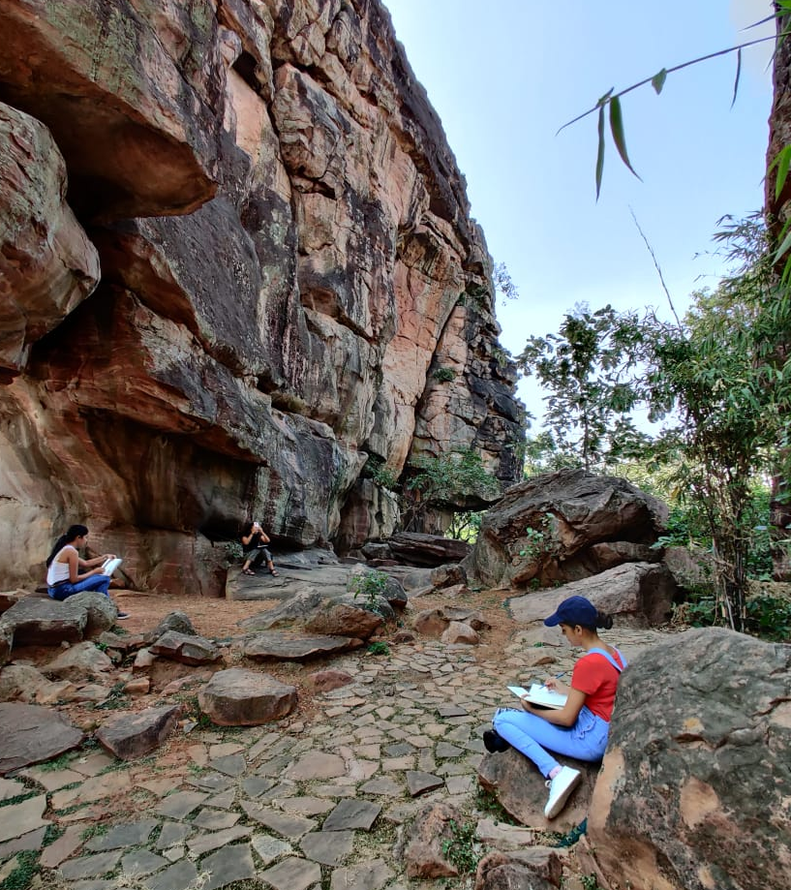
On return, we visited the Bhojeshwar temple at Bhojpur village, MP. It is an incomplete Hindu temple dedicated to Lord Shiva, It houses a 7.5 feet high lingam in its sanctum. The temple's construction is believed to have started in the 11th century, during the reign of the Paramara king Bhoja. the architectural plans engraved on the surrounding rocks. The unfinished materials abandoned at the site, the architectural drawings carved on the rocks, and the mason's marks have helped scholars understand the temple construction techniques of 11th-century India. The temple has been designated as a Monument of National Importance by the Archaeological Survey of India.
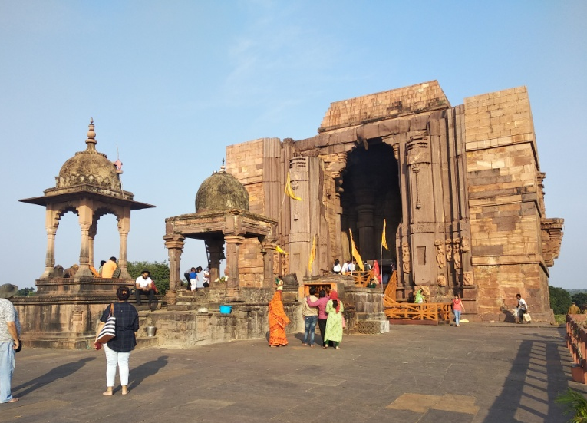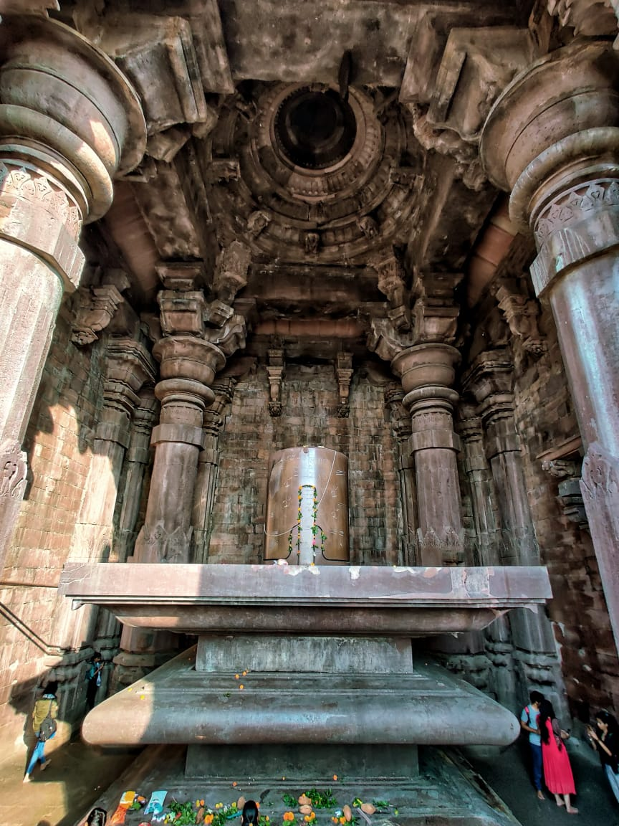
Day 5: 19.11.19
This was the most awaited day of the trip. A workshop was organized to learn the Gond art style. It was organized in collaboration with Mrs Padmaja Srivastava and Mrs Swati Rajoria of Artizen’s group. Presentation was given to explain the history, journey and technique. Two Gond tribal artists were also present and they gave demonstrations, interacted with the students and helped them learn the style. Students were taught to develop their own signature patterns as well. They were narrated folk-tales like ‘the flying elephant’, Stages of Entoxication’, ‘formation of earth etc. which the students depicted in their expressions in Gond art style. A very enriching and enthralling experience indeed.
The next destination got us refreshed. The ride through the Van Vihar National Park in Bhopal. The lake filled till the brim on one side and the reserve forest on the other was a fabulous experience. We spotted alligators, tiger, bear, dear etc, numerous types of birds and a section dedicated to snakes as well.
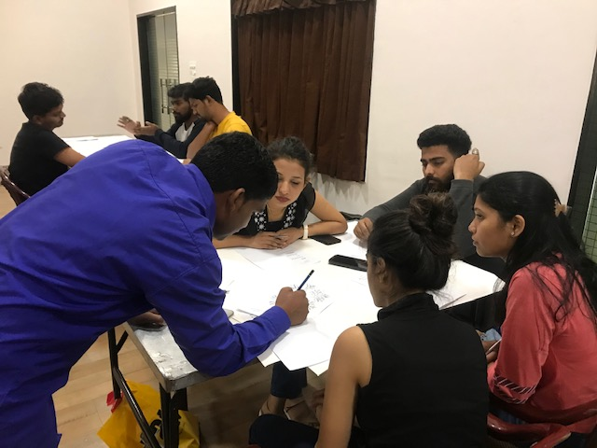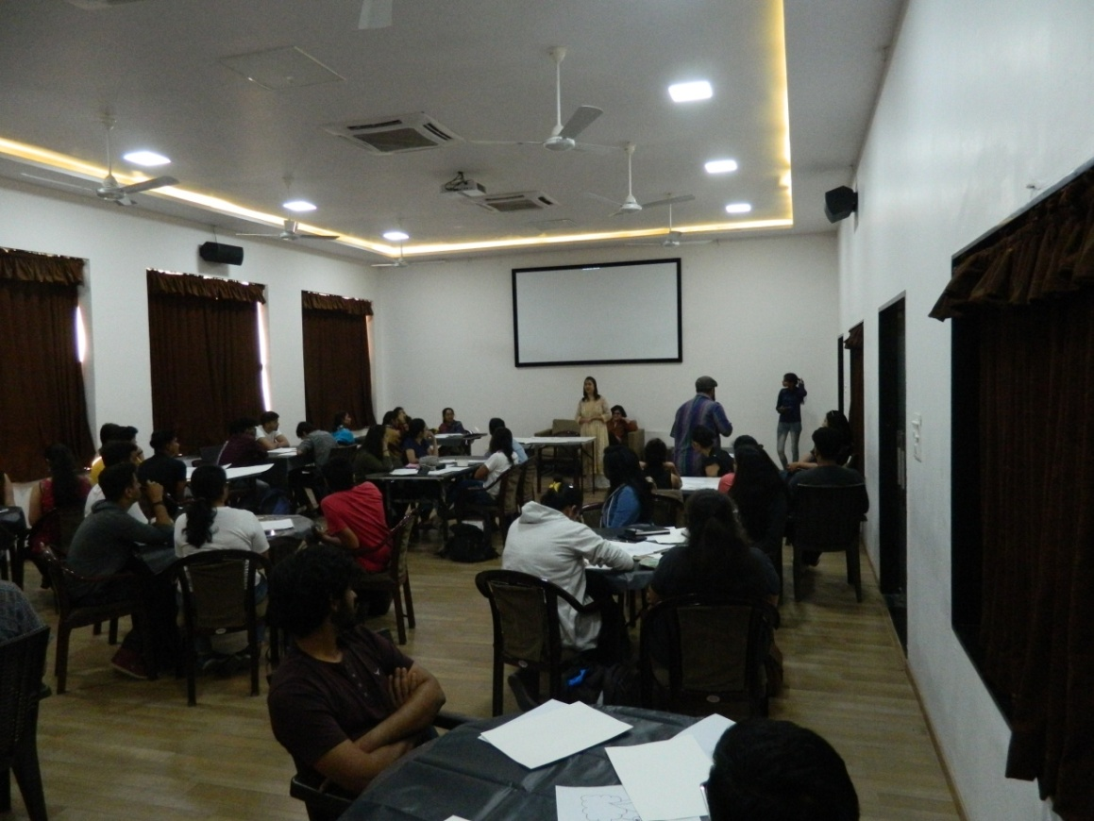
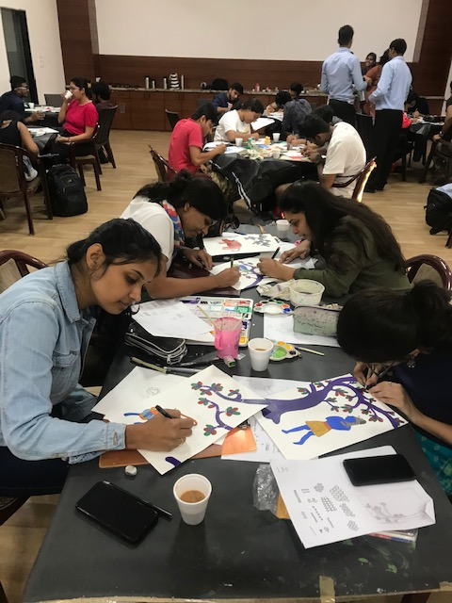
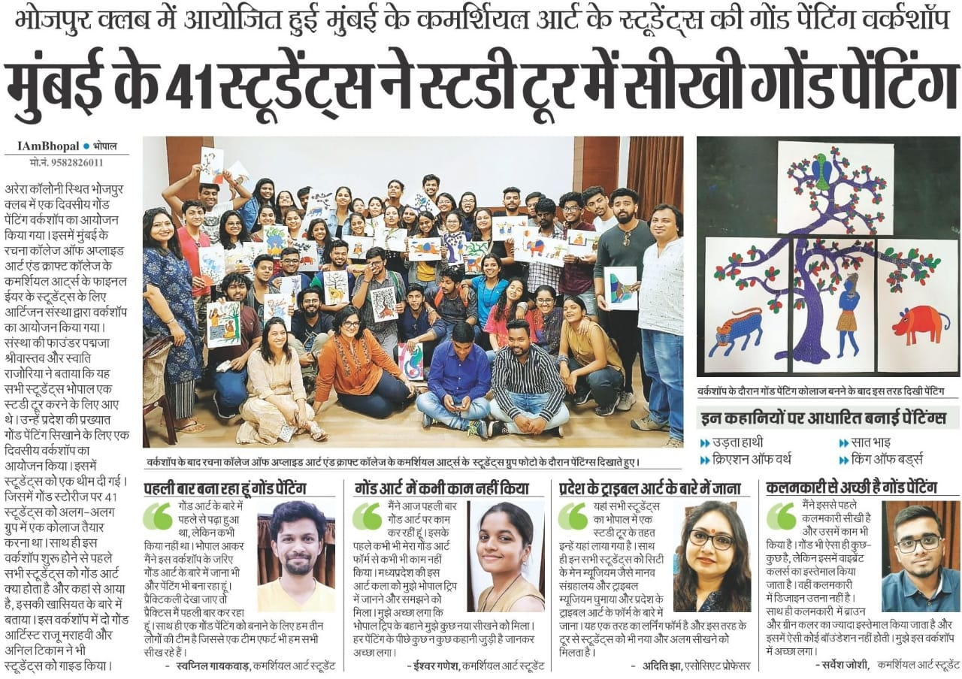
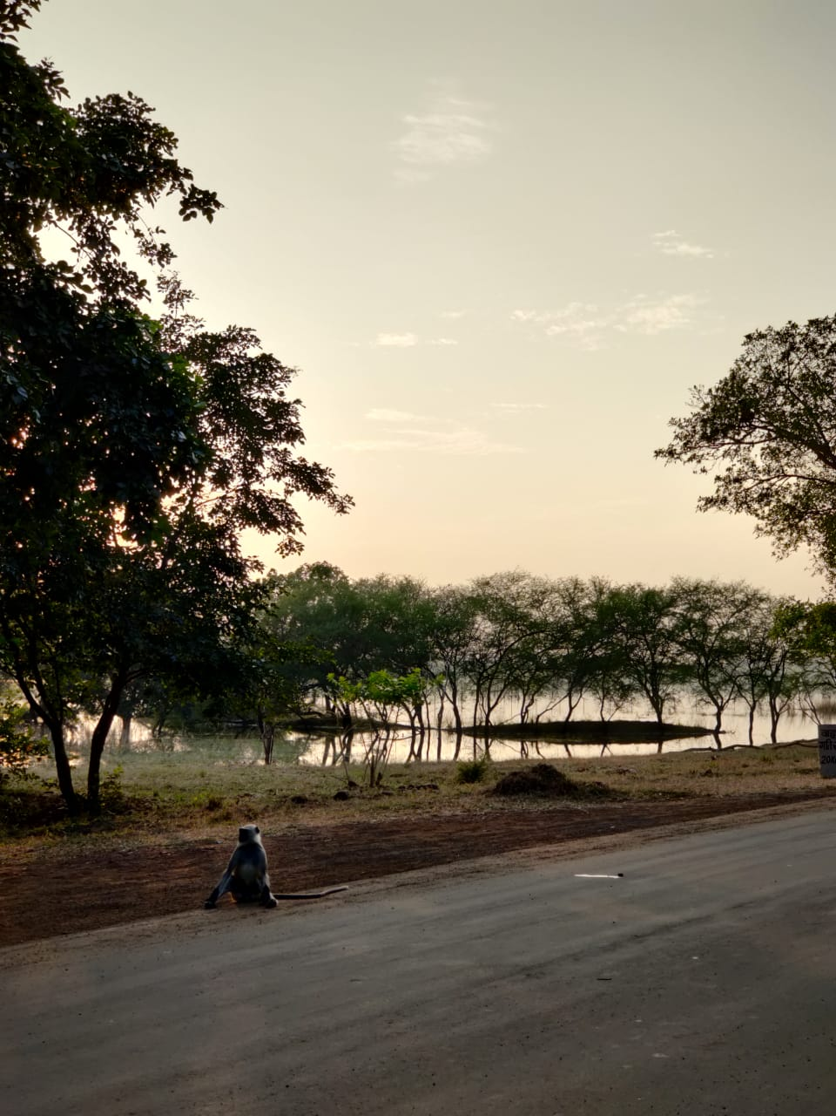
Day 6: 20.11.19
We started for Udaygiri after breakfast. The Udayagiri Caves are twenty rock-cut caves near Bhopal, Madhya Pradesh from the early years of the 5th century CE. They contain some of the oldest surviving Hindu temples and iconography in India. They are the only site that can be verifiably associated with a Gupta period monarch from its inscriptions. Unfortunately only 5 caves out of the 20 caves were open for viewing due to restoration work carried out by Archeological Dept.
The group stationed at Hotel Gateway Retreat, Sanchi. Post lunch students were taken to the Sanchi Stupa. The great stupa constructed in 3rd century BCE, is one of the oldest stone structures in India, and an important monument of Indian Architecture. The gateway to the stupa has immense historic and national importance. Students learnt about the illustrations of Jataka tales and other depictions of Buddha engraved on the stupa and the four gateways.
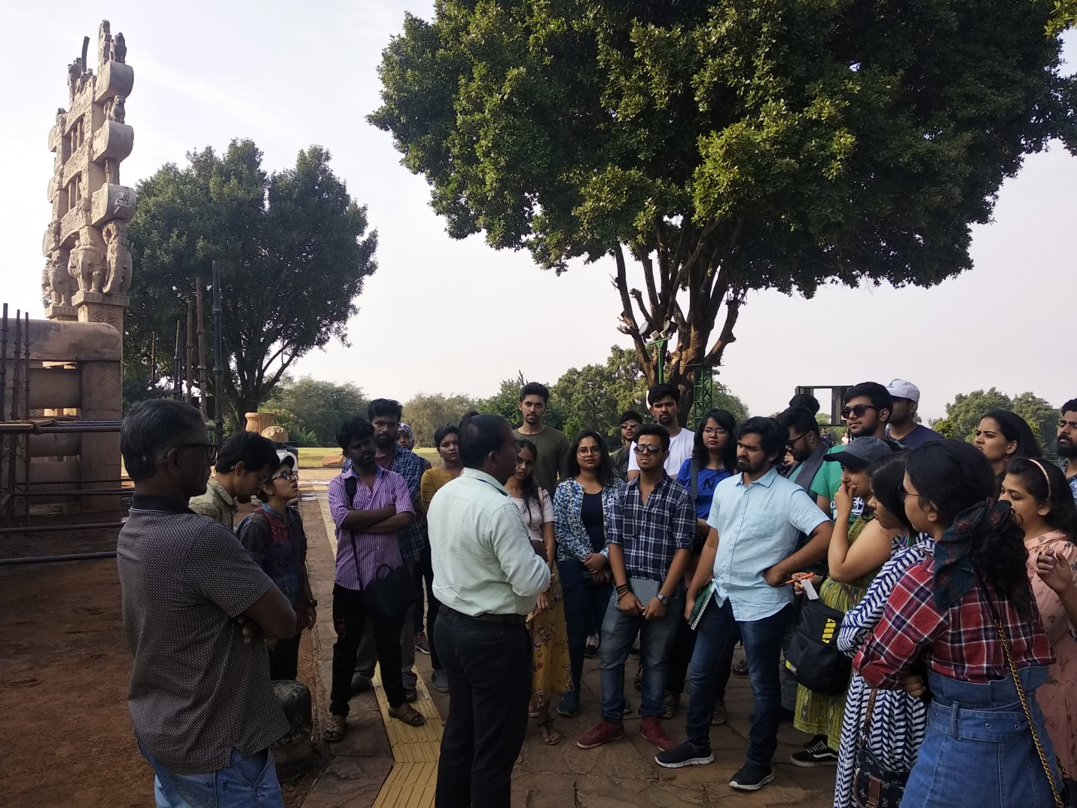
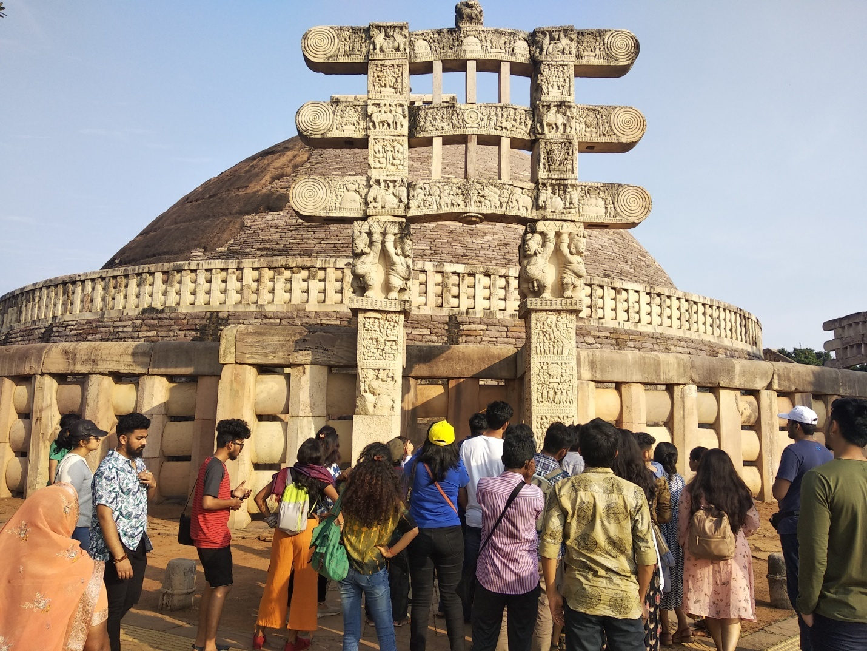
History in collaboration with technology, through a light and sound show mesmerized the students.
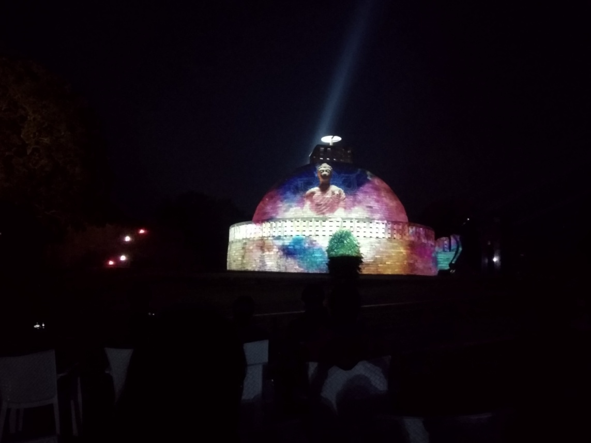
The most memorable part of the trip, the last dinner and the camp-fire was something that came as a surprise.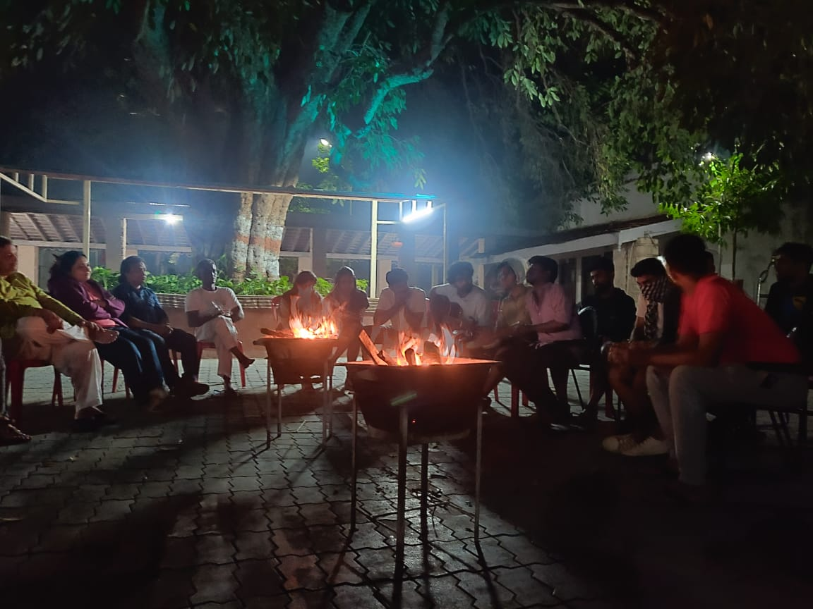

Day 7: 21.11.19
As all good things come to an end, so did the trip. The train for the return journey was from Bhopal by 12138 PUNJAB MAIL. The train was about 2 hrs delayed.
An overall wonderful trip, lots of knowledge, entertainment and fun.

Ms. Aditi Jha Mr. Vivek Tetwilkar Mr. Ameya Kadam
Associate Professor Assistant Professor Assistant Professor

